ZC35-J4125DL 3.5’’ Fanless Motherboard Onboard J4125 CPU,2*RJ45,6*USB,6*COM,VGA+HDMI+LVDS Display,SATA+M.2 Storage

Passive Fanless Cooling Design

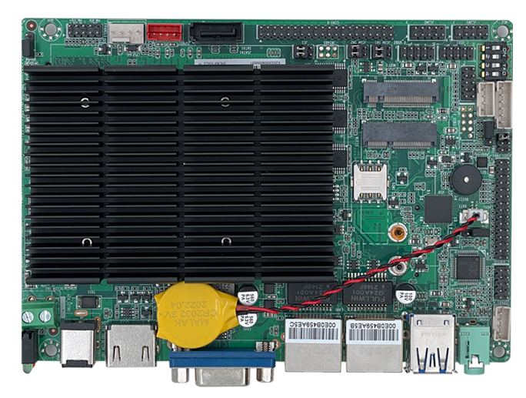

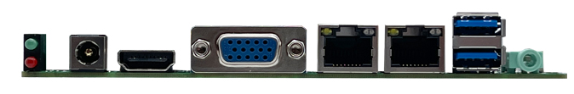

**Main Feature:**

1.) Onboard Intel Gemini Lake J4125,TDP only 10W

2.) Quad-Core 4 Threads 2.0GHz,Burst to 2.42GHz

3.) With VGA,HDMI,LVDS,Support Double Display

4.) Support 4*RS232+2*RS232/485

5.) With 1*Mini PCI-E,1*M.2 2230,1*SIM Slot

6.) Rich Storage,1*M.2 SSD Slot +1*SATA

7.) Onboard 2 Gigabit Ethernet Card

**ZC35-P4125DL 3.5’’ Motherboard**

|  |  |
| --- | --- |
| Model | ZC35-P4125DL |
| Processor | Intel Gemini Lake J4125  4 Cores 2.0GHz Burst to 2.7GHz  4MB Cache,TDP 10W |
| Memory | 1*SO-DIMM4,Max 8GB |
| Display | Intel Intel UHD Graphics 600 |
| 1* VGA,1*HDMI1.4, 1*LVDS |
| Support VGA, HDMI, LVDS synchronous/asynchronous dual display |
| Network Card | 2* Realtek RTL8111H Gigabit,Support Wake On LAN/PXE |
| Storage | 1* SATA3.0 |
| 1* M.2 2280 for SSD |
| Extension | 1* Mini PCIE slot |
| 1* M.2 2230 for WIFI |
| Audio | Onboard ALC662 6-channel high-fidelity audio controller, support MIC/Line-out, power amplifier 3W |
| Rear I/O | 1* HDMI |
| 1* VGA |
| 2* USB3.0 |
| 2* RJ-45 |
| 1* Line out(Green) |
| 1* Hard Disk/Power Indicator LED |
| 1* 12V DC |
| Internal I/O | 1* LVDS 2*15pin,Support Dual Channel 24bit |
| 1* Screen backlight power 1*6pin |
| 1* LVDS Power 2*3pin |
| 4* USB 2.0 2*5Pin |
| 1* Front Audio 2*5pin |
| 1* Speaker Amplifier 1*4pin |
| 1* SIM Card Slot 2*3Pin |
| 6* COM (COM2/COM3 Support RS485) |
| 1* SATA Slot |
| 1* SATA power header 1*4pin |
| 1* FAN header 1*4pin |
| 1* GPIO 2*5pin |
| 1* AT/ATX Header 1*3pin |
| 1* Front panel switch button and indicator light header 2*5Pin |
| 1* ATX 12V 1*2pin |
| Fan | Fanless heat dissipation design, 1* fan header 4pins reserved |
| Cooling System | Fanless Passive Cooling |
| GPIO | Support 4 input and output GPIO |
| BIOS | 64Mb Flash ROM |
| Watchdog | Support hardware reset function (256 levels, 0~255 seconds) |
| OS | Windows 7/Windows 10/Linux |
| Power Supply | DC 12V ±5% |
| Operating Temp | -10℃ to +60℃ |
| Storage Temp | -20℃ to +70℃ |
| Operating Humidity | 5% ~ 95% relative humidity, non-condensing |
| Size | 146mm x 102mm |